Project Executable Files

Date | 04 July 2026
Team ID | SWTID-2026-9778
Project Name | Credit Card Approval Prediction
Maximum Marks | 3 Marks

Project Executable Files
This section requires submission of all executable and deployable files for your project. Ensure all files are properly organized, named, and uploaded to the specified submission platform. The evaluator must be able to run or deploy your solution using the provided files and instructions.

Step 1: Submission Checklist

S.No | Item to Submit | Submitted (Yes / No / NA)
1 | Complete source code (all files and folders) | Yes
2 | README / Setup Guide (instructions to run the project) | Yes
3 | requirements.txt / package.json / dependency file | Yes
4 | Database schema / seed files (if applicable) | Yes
5 | Environment configuration file (.env.example or similar) | Yes
6 | Deployed application URL (if hosted) | No
7 | APK / Executable binary (if applicable for mobile/desktop apps) | NA
8 | Dockerfile / Containerization config (if applicable) | No
9 | Test files and test results | Yes
10 | Demo video or walkthrough (if required) | Yes

Step 2: File / Folder Structure
Provide an overview of your project's file and folder structure below:
Credit-Card-Approval-Prediction/
│
├── app.py
├── model.py
├── train_model.py
├── requirements.txt
├── README.md
├── credit_card_model.pkl
├── dataset/
│ ├── credit_card_dataset.csv
│
├── static/
│ ├── css/
│ ├── js/
│ └── images/
│
├── templates/
│ ├── index.html
│ ├── login.html
│ ├── register.html
│ └── result.html
│
├── database/
│ └── applicants.db
│
├── tests/
│ ├── test_prediction.py
│ └── test_api.py
│
└── screenshots/
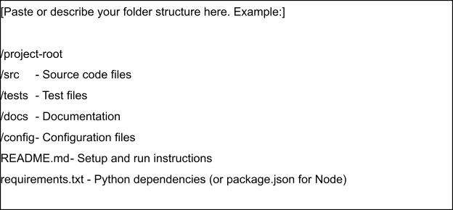

Step 3: Deployment / Access Details

Field | Details
Hosted / Deployed URL | https://creditcardapproval.up.railway.app/
Login Credentials (Demo) | Not required to login
Platform / Hosting Provider | Railways
Repository Link | https://github.com/Anilkumar7722/credit-card-approval-prediction
Demo Video Link | https://drive.google.com/file/d/19FXZRJe2AKuPqKh8Y6W33GmBxOrUN3Yv/view?usp=drivesdk

Step 4: Run Instructions
Provide clear, step-by-step instructions for the evaluator to run your project locally:
- Install Python 3.10 or later.
- Open the project folder in VS Code or PyCharm.
- Install dependencies:
pip install -r requirements.txt
- Run the Flask application:
python app.py
- Open your browser and visit:
http://127.0.0.1:5000
- Register or log in.
- Enter the applicant details.
- Click Predict to view the credit card approval result.

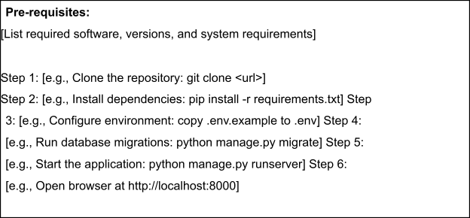

Step 5: Known Issues / Limitations

S.No | Known Issue / Limitation | Workaround / Status
1 | Model accuracy depends on dataset quality | Improve by using larger datasets
2 | No real-time bank API integration | Planned for future implementation
3 | Application currently supports local deployment only | Can be deployed to Render or AWS in future

